2018 GLENMORE SAILING CLUB summer youth sailing camps

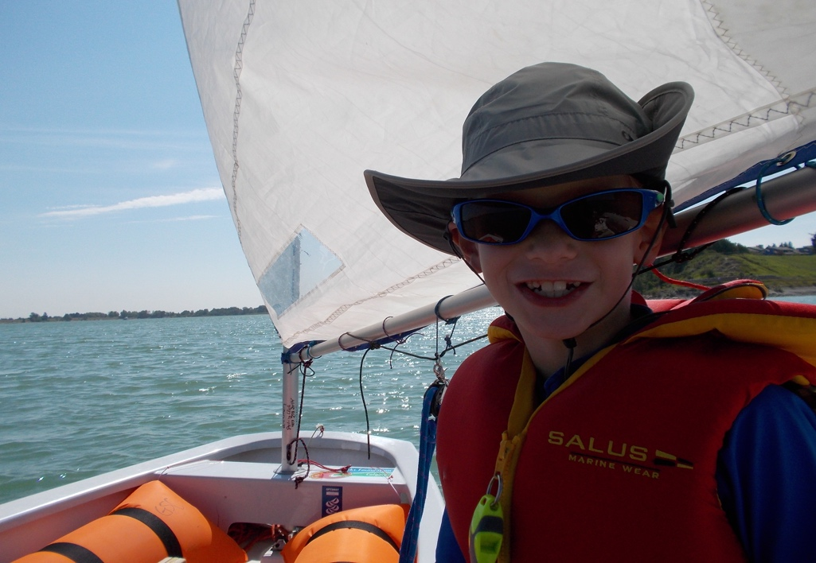

Introduction
The goal of the Glenmore Sailing Club summer youth sailing camp program is to provide children between the ages of 5 and 14 years of age a fun, safe, and informative environment to experience the sport of sailing.

Teaching children to sail helps them to develop life skills. In addition to learning how to rig, launch, and sail a boat, they will gain:
- Spatial awareness skills as they maneuver boats
- Direction finding abilities as they navigate the waters
- Self-confidence as they achieve success on their own and with others
- Accountability as they care for their own vessel
- Various other skills and abilities

We offer Sail Canada’s CanSail program, delivered by Sail Canada certified coaches.

GENERAL INFORMATION AND FREQUENTLY ASKED QUESTIONS
How do I know which class to register my child for?
For registration in any of our courses, we ask that participants fit within our age ranges. Participants should be comfortable with water-based activities.

- Wet Feet is a half day, week long introduction class designed for children between the ages of 5 and 7. The primary focus of this course is to provide a fun and safe introduction to the sport of sailing. Skills that are focused on during this course include:
  - Ashore skills: boat parts, safety
  - Afloat skills: steering, balance, safety

- CanSail 1 is a full day, week long introduction class designed for children between the ages of 8 and 13. The primary focus of this course is to provide a fun and safe introduction to the sport of sailing. There are no pre-requisites for this course. Skills that are focused on during this course include the basics of:
  - Balance
  - Sail Trim
  - Direction
  - Head Up
  - Bear Off
  - Tacking
  - Gybing
  - Stop/Go
  - Slow Down/Speed Up
  - Seamanship
  - Physical Literacy

- CanSail 2 is a full day, week long intermediate class designed for children between the ages of 8 and 13. Children enrolled in this class must have completed their CanSail 1. Skills that are focused on during this course include:
- Building upon each skill category introduced in CanSail 1
- Tactics/Strategy

- Cansail 3+ is a full day, week long advanced course for children between the ages of 9 and 14. The prerequisite for this class is completion of CanSail 1 and CanSail 2. Skills that are focused on during this course include:
- Building upon each skill category introduced in CanSail 2
- Content will be taken from CanSail 3 through 6. Lessons will be tailored to the sailors in the group

- We encourage all participants to progress through our summer camp programs and upon completion of CanSail 3, we recommend joining the GSC Youth Race Team

What hours do the camps run?
- Full day camps run Monday through Friday, 09:00-16:00
- Wet Feet camps run Monday through Friday, 09:00-12:00 OR 13:00-16:00

Is there before and after camp supervision available?
- When registering, before and/or after care can be selected as an option
- Before Care: 08:00-09:00, After Care: 16:00-17:00
- The charge is an additional $30 per week for each selection
- Activities will be available throughout this time to entertain participants but there will be no sailing instruction
- We understand that it can be difficult to arrive exactly on time for pick up and drop off. Therefore, we allow for a 15-minute window. Please be advised that if you are early or late for drop off or pickup respectively on more than one occasion, you will be invoiced for the before and/or after camp supervision cost

What does my child need to bring each day?
- Each child must bring their own Ministry of Transportation (MOT) approved lifejacket as lifejackets must be worn at all times while on the reservoir (according to City of Calgary By-Laws and club program rules). Camp participants will not be allowed to take part in on water activities without one. When shopping for a lifejacket, have your child try it on in the store to ensure that it is comfortable, allows for a full range of motion, is designed for someone in their weight category, and allows them to sit cross legged comfortably. You should be able to pull up on the shoulder material (with your child’s arms straight up in the air) and the lifejacket should not slip over their head.
- In addition to a lifejacket, the following items must come to camp each day:
  - Sunscreen
  - Refillable water bottles
  - Hat
  - Change of clothes
  - Towel
  - Closed toes shoes (able to get wet, allow for running)
  - Bagged lunch that does not require a microwave
  - Jacket or windbreaker in case of rain or cooler conditions

How does the CanSail program work?
- CanSail is not a pass or fail system
- Because sailing is a weather dependent sport, it might be difficult to get through all the on-water content some weeks. If a level is not attained and a sailor is left “in progress”, children should not be discouraged because sometimes it is out of their control

2018 SCHEDULE
DATE | COURSE | PRICE
July 2-6 | CanSail 1 | $385
July 9-13 | CanSail 1 | $385
July 16-20 | CanSail 2 | $385
July 23-27 | WetFeet AM | $235
July 23-27 | WetFeet PM | $235
Aug 6-10 | CanSail 1 | $385
Aug 13-17 | CanSail 2 | $385
Aug 20-24 | CanSail 3+ | $385
Aug 27-31 | CanSail 1 | $385

REGISTRATION
To register, please visit our Sail Canada affiliated Checklick website:
https://glenmoresailingclub.checklick.com

- Membership discount: The membership discount is only valid for those children who have a parent with an individual or family membership (not a social or crew membership) or for those children who have a junior or student membership. If you register for the membership discount without an appropriate membership that has been paid in full for the current year, you will be invoiced for the difference
- KidSport discount: The KidSport discount is only available for those who have been approved via our application process. If you register for the KidSport discount without being approved, you will be invoiced for the difference. For more information regarding this program, please visit: https://www.glenmoresailingclub.com/kidsport

CONTACT
For more information, please contact:
Paula Patterson
Youth Coordinator
youth@glenmoresailingclub.com
*Please be advised that we are a volunteer run non-for profit organization. The best way to contact our volunteers is via email.

